**DESIGN AND ANALYSIS OF ALGORITHM**

**NAME:ENIYA.B.A  
ROLL NO:230701085**

Finding Complexity using Counter Method

**Problem-1:**

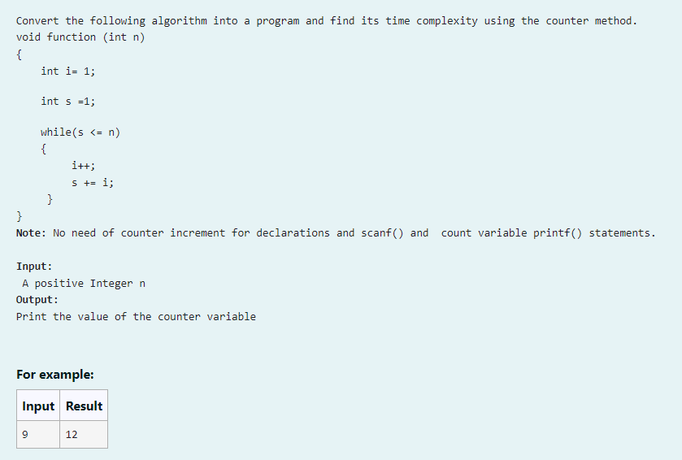

**CODE:**

#include<stdio.h>

int main(){

int n;

scanf("%d",&n);

int a=0;

int i=1;a++;

int s=1;a++;

while(s<=n){

a++;

i++;a++;

s+=i;a++;

}

a++;

printf("%d",a);

}

**OUTPUT:**

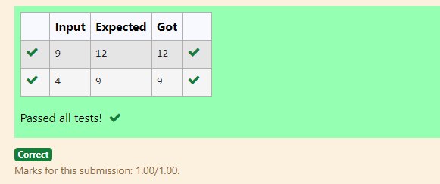

**PROGRAM-2:**

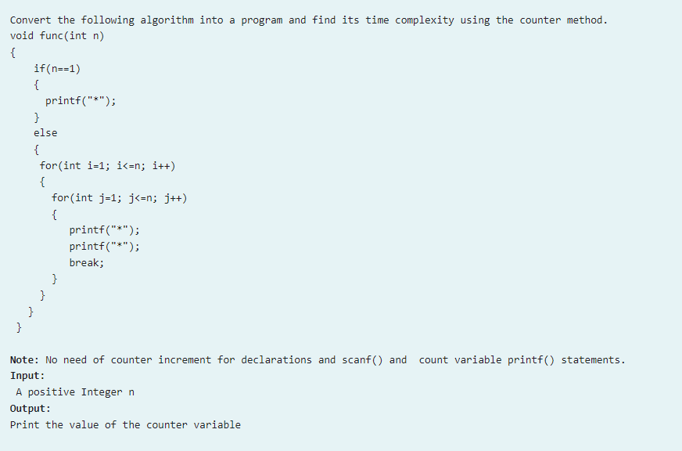

**CODE:**  
#include<stdio.h>

int main(){

int n,a=0;

scanf("%d",&n);

if(n==1){

a++;

//printf("*");

}

else{

a++;

for(int i=1;i<=n;i++,a++){

a++;

a++;

for(int j=1;j<=n;j++,a++){

a++;

//printf("*");

//printf("*");

break;

a++;

}

a++;

}

a++;

}

printf("%d",a);

}

**OUTPUT:**  
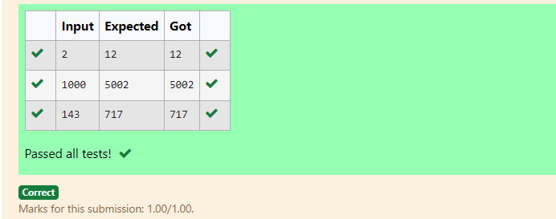

**PROGRAM-3:**

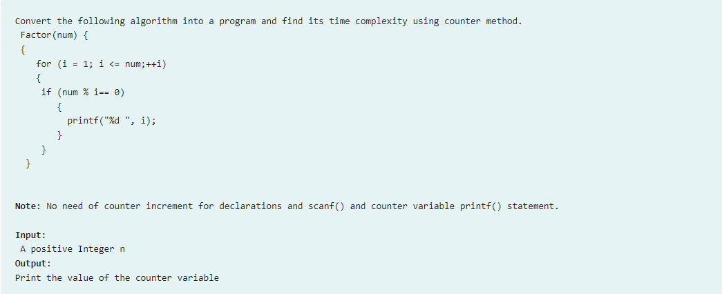

**CODE:**

#include<stdio.h>

int main(){

int num,a=0;

scanf("%d",&num);

for(int i=1;i<=num;++i,a++){

a++;

if(num%i==0){

a++;

//printf("%d ",i);

}

}

a++;

printf("%d",a);

}

**OUTPUT:**

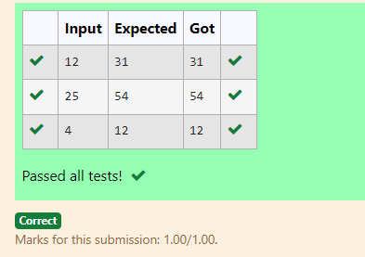

**PROGRAM-4**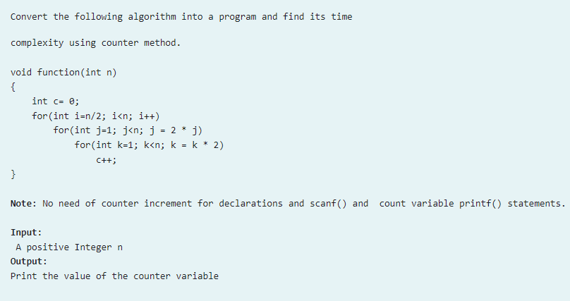:

**CODE:**

#include<stdio.h>

int main(){

int n,a=0;

scanf("%d",&n);

int c=0;

a++;

for(int i=n/2;i<n;i++){

a++;

for(int j=1;j<n;j=2*j){

a++;

for(int k=1;k<n;k=k*2){

a++;

c++;

a++;

}a++;

}a++;

}a++;

printf("%d",a);

}

**OUTPUT:**

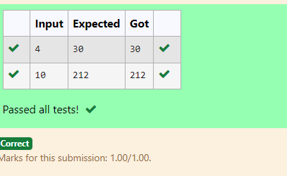

**PROGRAM_5:**

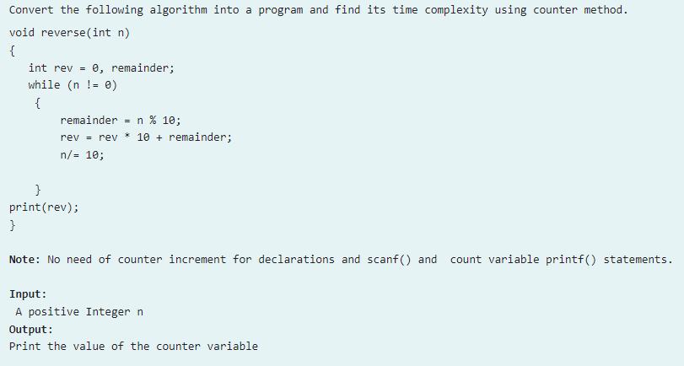

**CODE:**

#include<stdio.h>

int main(){

int n,a=0;

scanf("%d",&n);

int rev=0;

int remaider;

a++;

a++;

while(n!=0){

a++;

remaider=n%10;

a++;

rev=rev*10+remaider;

a++;

n/=10;

a++;

}a++;

//printf(rev);

printf("%d",a);

}

**OUTPUT:**

